DIS-EUR-Cucuteni Fig.-Draguseni-Romania

Cucuteni Female Figurine, fired clay, 4050-3900 cal BCE, Drăguşeni, Botoşani County, Romania. Atlantika Collection

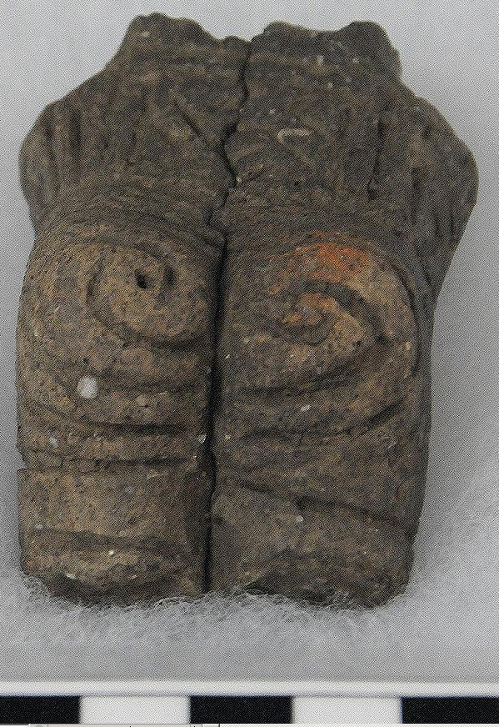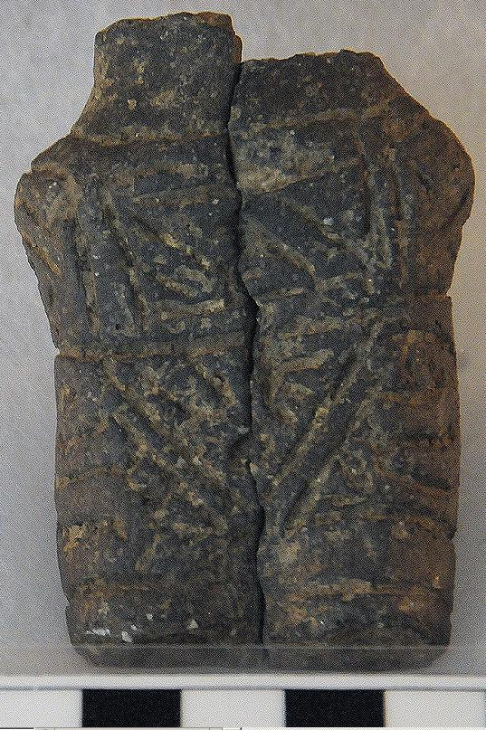

Fig 1 a-b. Cucuteni Female Figurine, fired clay, 4050-3900 cal BCE, Drăguşeni Botoşani County, Romania. Atlantika Collection.

Formal Label: Cucuteni Female Figurine, fired clay, 4050-3900 cal BCE, Drăguşeni Botoşani County, Romania. Atlantika Collection.

Accession Number: GN776.2.C83.A1

Date or Time Horizon: 4050-3900 cal BCE

Geographical Area: Drăguşeni Botoşani County, Romania.

Cultural Affiliation: Cucuteni

Media: Fired Ceramic

Dimensions: **H in. ,W in. ,D in; H cm. ,W cm. ,D cm.**

Weight: lbs., oz.; gm.

Provenance: old German collection; then Atlantika collection.

Female ceramic figurines predominate in 6th millennium BCE Old European material culture in Southeastern Europe. The term "Old Europe" is derived from Marija Gimbutas’ (1921 - 1994) 1974 inspiring work. As a Lithuanian archaeologist she argued that a culture oriented to feminine concerns flourished in the Neolithic of Old Europe with farming of wheat and domestication of herded animals and where female-centered goddess worship prevailed. Cucuteni - Tripolye villages were circular on raised ground and usually fortified (Marinescu-Bilcu 1993). In the event they were burned (for reasons unknown) figurines were often broken and/or fragmented (for reasons unknown) and have been subsequently found when they were excavated inside burned houses.

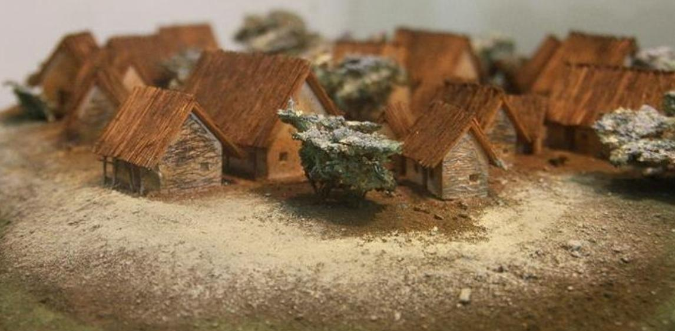

Fig 2. A model Cucuteni village around which there was probably a palisade of twenty-foot trees lashed together for protection against marauders. After <https://romaniadacia.files.wordpress.com/2014/05/cucuteni-village>

-cucuteni-trypillian-culture-romania-moldova-ukraine-oldest-civilizations-eastern-europe2.jpg

Furthermore, there were no necropoli outside of the villages, which would have indicated a hierarchical society. However, single adult males were buried with their weapons in solo graves. So, a resolution to the peaceful versus war-prone model is needed, since from the archaeological evidence social tensions were a factor on the Southeastern European countryside in the 6th and 5th millennia BCE.

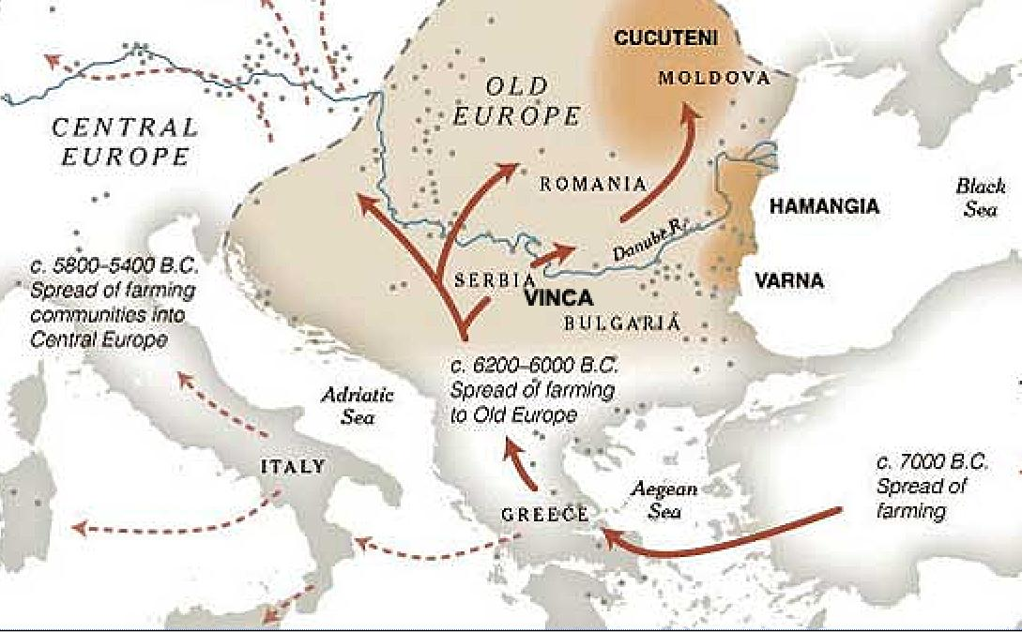

Fig. 3. Modified map of Old Europe Neolithic Cultures by Jonathan Corum, in the New York Times, December 1, 2009. After http://www.nytimes.com/imagepages/2009/12/01/science/01arch_graphic.html

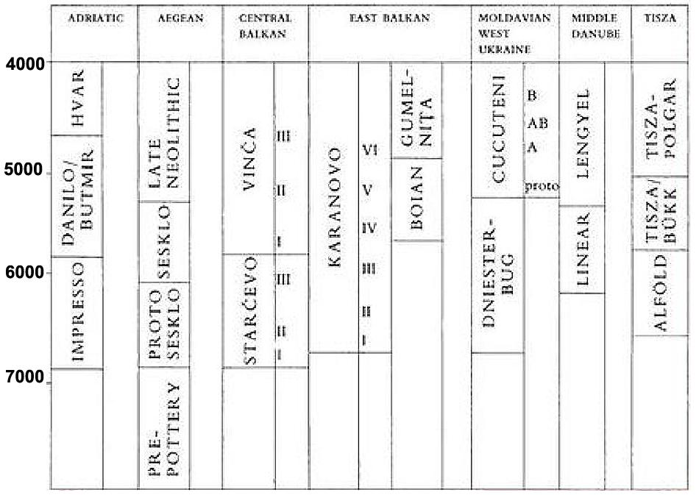

Fig. 4. The cultures of Old Europe with calibrated radiocarbon dates

on the left giving true BCE dates after the Suess calibration curve. From http://www.eliznik.org.uk/EastEurope/History/balkans-map/index.htm

The Neolithic trajectories continued into the Chacolithic period with the emergence in the 5th millennium of complex societies, the use of copper tools, social differentiation and enigmatic inscribed signs that are found infrequently on ceramics including ont Cucuteni A/ Tripolye B figurines (Bailey 2000, Marinescu-Bilcu and Bolomey 2000, Whittle 1996). Cucuteni refers to phases A, A/B and B, while Tripolye refers to Phases BI, BII and C I, and C II (Dumitrescu 1978; Mantu et al 1997). These Cucuteni A/ Tripolye B figurines can be found represented individually as well as in large groups, and in contexts identified as domestic, ritual, religious, and funerary. Ceramic production reflected expert workmanship in painted ceramics, coarse ware for utilitarian use and miniature, incised anthropomorphic and zoomorphic figurines for possible ritual functions (See below and Anthony and Chi 2010).

While a common grammar of the incised figurines encompassed Cucuteni A/ Tripolye B figurines, local styles emerged which allows us to identify the origins of some of these ceramic productions. In the Atlantika example, for instance, the figure had been purposefully broken, an act that could be construed to incapacitate its power. Furthermore, the torso that remains has the typical Cucuteni A/ Tripolye B stylistic grammar of bands of incised parallel lines in bands that intersect with others at angles approaching 90 degrees. This suggests that these bands represent some kind of body covering. However, in certain areas of the entire figurine (Fig. 5 below) there are departures from this banding. They are in three zones: at the head and neck, at the genital area and at the buttocks.

In the specimen we have, only the lower torso is present, and the buttocks have mirrored spirals on each cheek. Only at the Drăguşeni site dated to 4050–3900 BCE, in Botoşani County, Romania, is this convention followed. This suggests that regardless of the use of this figurine it provided a local Drăguşeni community identity with this mirrored spiral. In addition, during the 150 years these miniature figurines were made, its overall stylistic grammar provided the users of this figurine with a larger Cucuteni group identity.

It also happens that the miniature size of these figurines also plays a role in their psychological interpretation. Psychologist Alton J. DeLong (1981) showed that when subjects were given three models of waiting rooms (1/6, ½, 1/24) of actual size and were told to imagine themselves in each of these environments the subjects reported that after having waited a real time of 30 minutes they estimated the elapsed time to be 5.43 min., 2.66 min., 1.49 min. respectively. Time had collapsed simultaneously with their viewing reduced size environments. “Subjects observing differently scaled environments undergo systematic shifts in the experience of time. The experience of temporal duration is compressed relative to the clock in the same proportion as scale-model environments being observed are compressed relative to the full-sized environment. This research suggests that spatial scale may be a principal mediator in the experience of time.” “Spatial scale as defined here is based on the linear dimension, not volume. A wall 12 m long represented by a model in which the wall is 1 m long yields a linear scale of 1/12, while the volumetric reduction is 1/1728 (1/123)” (DeLong1981:681). If this evidence were applied to viewing miniature figurines, which are approximately on the order of 1/24 of actual size of a human figure, then their one’s viewing time would be expanded as well. What would have originally have taken 600 minutes of actual real time in a full-size setting could be accomplished in a 1/24 miniature setting with a *perceived elapsed time* of 20.134 minutes! This suggests that space and time are psychologically relative to one another and may have serious implications on neurological functions and CNS sensitivity. For instance, “34 undergraduates played a series of video games on small or large screen TVs in a counterbalanced order. Results show a significant increase in scores on the small screen relative to the large screen after practice effects were eliminated. Games on the small screen were also significantly shorter, suggesting that scale changes may permit higher levels of performance in less time, but they were experienced as longer than those played on the large screen. These results indicate a relationship among spatial scale, temporal experience, and information processing. It is suggested that the higher performance on the smaller screen reflects a shift in attentional focus stemming from a transformation of the time framing of the nervous system” (DeLong 1983).

This implies that enhanced attentional focus on the miniature figurines has a role to play not only in a temporal experience but also in the depth of sensitivity and awareness, key attributes of meditation. Therefore, the implications for the use of these miniature figurines suggest that they were used, at least in part, for meditation.

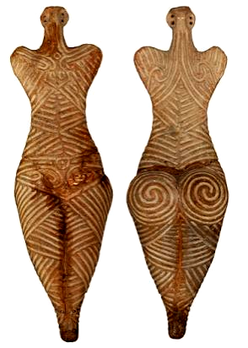

|----|----|----|----||----| 5 cm

Fig. 5 a-b. Cucuteni Female figurine, fired clay, 4050-3900 cal BCE, Drăguşeni, Botoşani County Museum, Botoşani: 7558. Photo: Marius Amarie.

REFERENCES

Anthony, David W. and Jennifer Chi. 2010. *New York, Institute for the Study of the Ancient World at New York University*. Princeton, N.J. | Oxford, Princeton University Press, 2010.

Bailey, Douglas. 2000. *Balkan Prehistory : Exclusion, Incorporation, Identity*. London: Routledge.

DeLong, Alton J. 1981. Phenomenological Space-Time: Toward an Experiential Relativity, *Science* 213: 681-683.

DeLong, Alton J. 1983. Spatial scale, temporal experience and information processing: An empirical examination of experiential relativity, *Man-Environment Systems*, 13(2): 77-86.

Dumitrescu, V. 1978. *Arta Cultura Cucuteni*. Bucuresci: Editura Meridiane.

Mantu et al 1997).

### Marinescu-Bîlcu, S., 1993. Les Carpates orientales et la Moldavie. *Atlas du Néolithique européen*, 1:191-241.

Marinescu-Bilcu, S. and A. Blomey. 2000. *Drăguşeni, a Cucutenian Community*. Bucuresci, Romania: Editura Enciclopedikă.

Monah, D. and Monah F. 1997. "The Last Great Chacolithic Civilization of Old Europe”, in C.-M Mantu, G. Dumitroaia and A. Tesaravopoulis, eds., *The Last Great Chacolithic Civilization of Old Europe.* Thessaloniki, Athena Publishing.

Whittle, A.W. 1996. *Europe in the Neolithic: the creation of new worlds*. Cambridge: Cambridge University Press.